**DEPARTMENT OF COMPUTER SCIENCE AND ENGINEERING**

**ST JOSEPH ENGINEERING COLLEGE, Mangaluru**

**2022-2023**



**Synopsis and Design Phase Report**

On

**Miniproject Title**

*Submitted by*

Melroy Dsa 4SO20CS086

Preeona Mendonca 4SO20CS110

**ABSTRACT**

The newly founded music club of St. Joseph Engineering College named “Crescendo”, has a lot of members to cater for in the club’s activities and projects in each semester. Both the coordinators and members find it difficult to keep everything organized and updated. Since almost everyone has a handheld or a mobile device such as laptops, tablets etc. having a digital record is a convenience to all the students involved in it.

This project provides an easier insight to each member in regards to the current activities by the club, tasks, involvement, in it etc. and also people outside the club can view the club’s events, history and so on.

**ACKNOWLEDGEMENT**

We dedicate this page to acknowledge and thank those responsible for the shaping of the project. Without their guidance and help, the experience while constructing the dissertation would not have been so smooth and efficient.

We sincerely thank **Ms Supreetha D R, Assistant Professor**, Department of Computer Science and Engineering for his guidance and valuable suggestions which helped us to complete the project.

We owe our profound gratitude to **Dr Sridevi Saralaya**, **Head of the Department**, Computer Science and Engineering, whose kind consent and guidance helped us to complete this work successfully.

We are extremely thankful to our **Director, Rev. Fr Wilfred Prakash D'Souza**, our **Principal, Dr Rio D’Souza**, and **Assistant Director, Rev. Fr Alwyn Richard D’Souza** for their support and encouragement.

We would like to thank all our Computer Science and Engineering staff members who have always been with us extending their support, precious suggestions, guidance and encouragement throughout in all possible ways.

We also extend our gratitude to our friends and family members for their continuous support.

**Table of Contents**

Abstract……………………………………………………………………….…………..i

Acknowledgement……………………………………………………………………. ...ii

Contents………………..………………………………………………………………04

List of Tables & Figures………...………………………………………………………05

1. Introduction…………………………………………………...……………….…. 06

1.1 Problem Definition………… ………………………..……...……………...06

1.2 Scope & Importance…………………………………………………….......07

2. Software Requirement Specification…….…… ………………………..……….... 08

2.1 Functional Requirements……..…..……….……………………...………08

2.2 Software Requirements…………………………………………………..09

2.3 Hardware Requirements………………………………………..….……...10

3. System Design……………………………………………………….……….…… 11

3.1 ER Model……………………………………………………..…….….…... 11

3.2 Schema Description………………………………………..………....…..… 12

3.3 Tables Description……………………………………...………..….……… 13

4. Stored procedure and Trigger Implementation ……………..……………………….16

5. Screenshots………………………………………………..……………………...

6. Conclusion and Future work……………………………..……………………….

**LIST OF TABLES AND FIGURES**

1. ER Model………………………………………………………….…................................ 05

2. Schema Diagram…...………………………………….………………………………….. 06

3.Home....……….……………………………………………………………………….….... 07

4. Events ...………….………………………………………………………….......…............07

5. Gallery……...…..……………………………………….………………………..……........ 07

6. About....………………………………………………………….………………….………..08

7. Contact……....………………………………….……….…….........................................09

8. Login……….….....……………………………………………....………………….……….10

9. Display Details….….....……………………………………………....……….………….…10

10. Delete Details…………………………………………………………………………..…..11

**CHAPTER-1 INTRODUCTION**

In order to allow the organization's administrator to access, find, and change a member's personal information while allowing the member to manage his profile, Crescendo-The Music Club was created. The management of student data, such as names, IDs, email addresses, and phone numbers, would be made simpler. So, in a couple of seconds, all of a member's information will be available.

Overall, both the administrator and the club members will find it simpler to move the Music Club as a result of this. The major objectives of this SRS document are to give examples of the specifications needed for the Music Club project and to help the organization manage and protect the personal data of its members.

**1.1 PROBLEM DEFINITION**

When students were controlled manually, which involves writing down every piece of information in a book or on paper, the administrator's task became more challenging and time-consuming. It's feasible that the records will vanish or be obliterated in the event of an accident. The Club manages student data using computers, though.

They use a variety of systems, each of which is separate and has a specific function. The same data and information must be entered into each system for it to operate independently when different systems are operated separately.

**1.2 SCOPE & IMPORTANCE**

The Music Club offers the capability for managing schedules, student attendance records, the enrolling process, and other student-related data needs. All the tasks that have been uploaded to the members can be monitored by them. They can post their views as well. Additionally, all announcements will be published.

**CHAPTER-2 Software Requirement Specification**

**2.1 Functional Requirement Specification**

**Administrator Login:**

In this module we can do the following:

•Admin should be able to insert, modify and delete .

•Can get the information of any student who has admitted .

•Add and edit any information by categories.

**Member Admission:**

In this module we can enter new member details.

**View member details:**

In this module we can view the member details.

**Update member details:**

In this module we can keep updating the member details.

**Delete member details:**

In this module we can keep deleting the member records.

**2.2 Software Requirements Specification**

**Client Side**

**-Web Browser :**

Google Chrome

**-Software:**

XAMPP(PHP,MySql,Apache)

**Server Side**

**-Web Browser:**

Google Chrome

**-Software:**

XAMPP Server (Apache)

**Tools used**

Operating System: Windows 7 or higher

Language: PYTHON, SQL

Database: mysql

IDE: Visual Studio Code

**2.3 Hardware Requirements Specification**

**Client Side**

-Processor:

Intel i5 2.4 GHz

-RAM:

512 MB

-Hard Disk:

10GB

**Server Side**

-Processor:

Intel i5 2.4 GHz

-RAM:

4 GB

-Hard Disk:

50GB

**CHAPTER-3 SYSTEM DESIGN**

**3.1 Entity**

-Relationship Diagram

An Entity Relationship(ER) diagram is a type of flowchart that illustrates how “entities” such as people, objects or concepts relate to each other within a system.

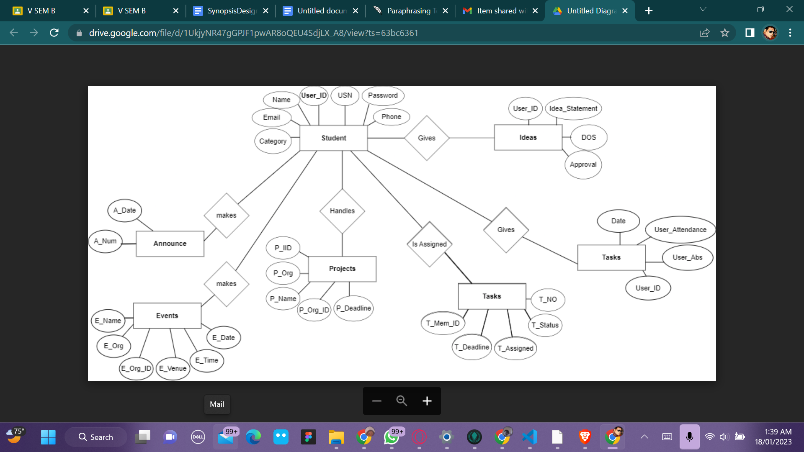

**Fig 3.1: ER diagram of Crescendo-The Music Club**

**3.2 Schema Diagram**

A schema is a collection of database objects. A schema is owned by a database user and has the same name as that user. Schema objects are logical structures created by users.

Objects such as tables or indexes hold data, or can consist of a definition only,such as a view or synonym.

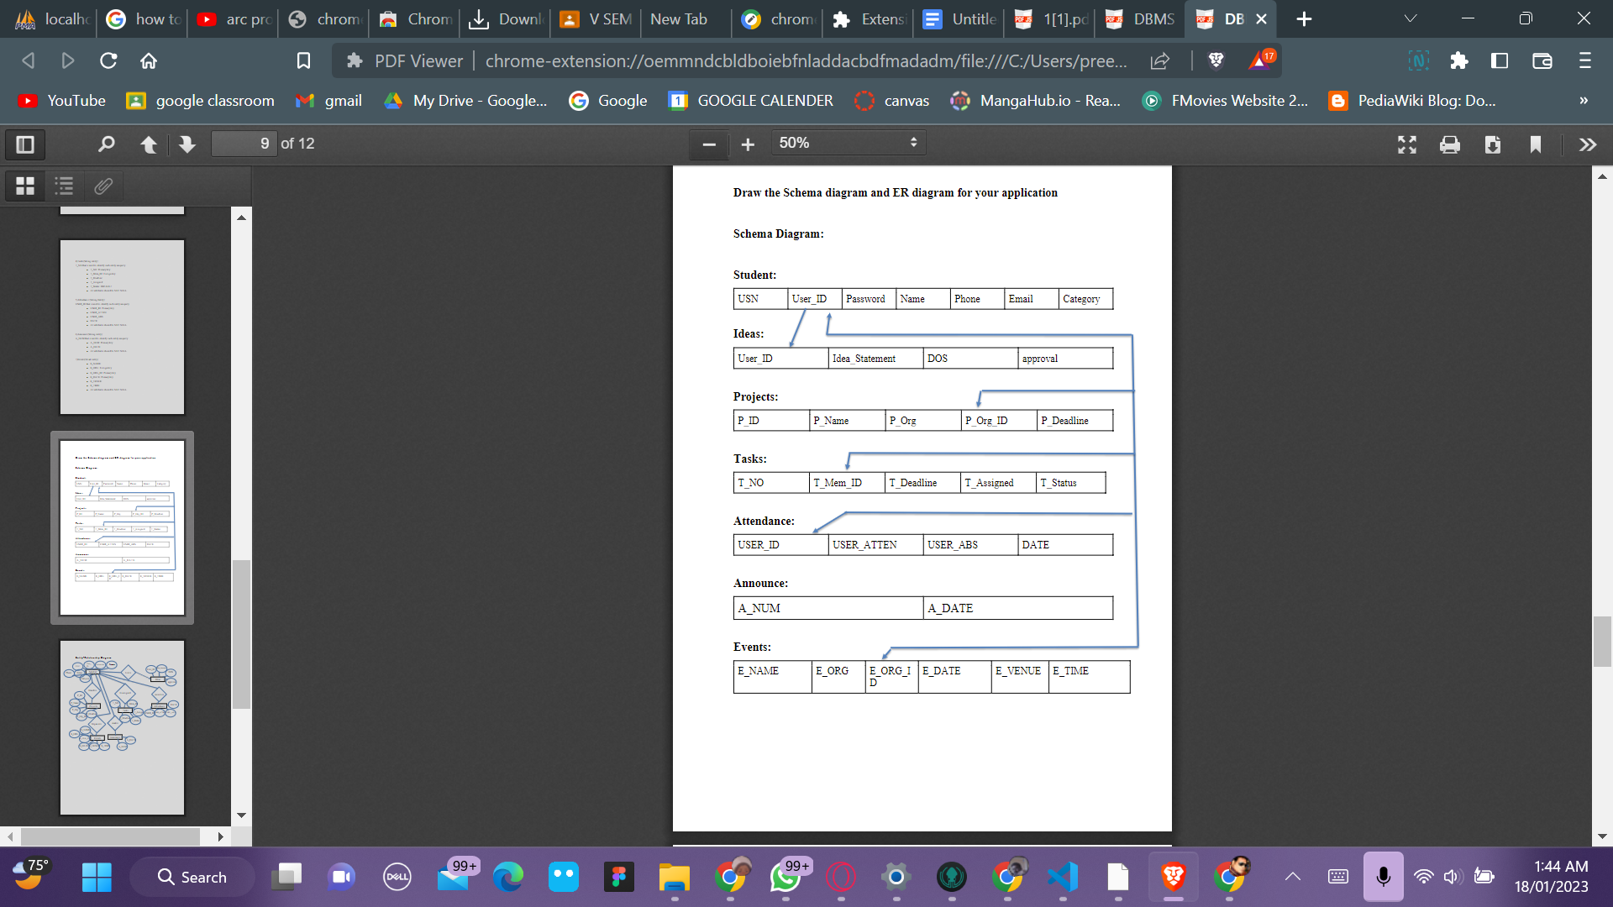

**Fig 3.2 Schema Diagram of Crescendo-The Music Club**

**3.3 Table Description**

**Table 3.3.1 Student Record**

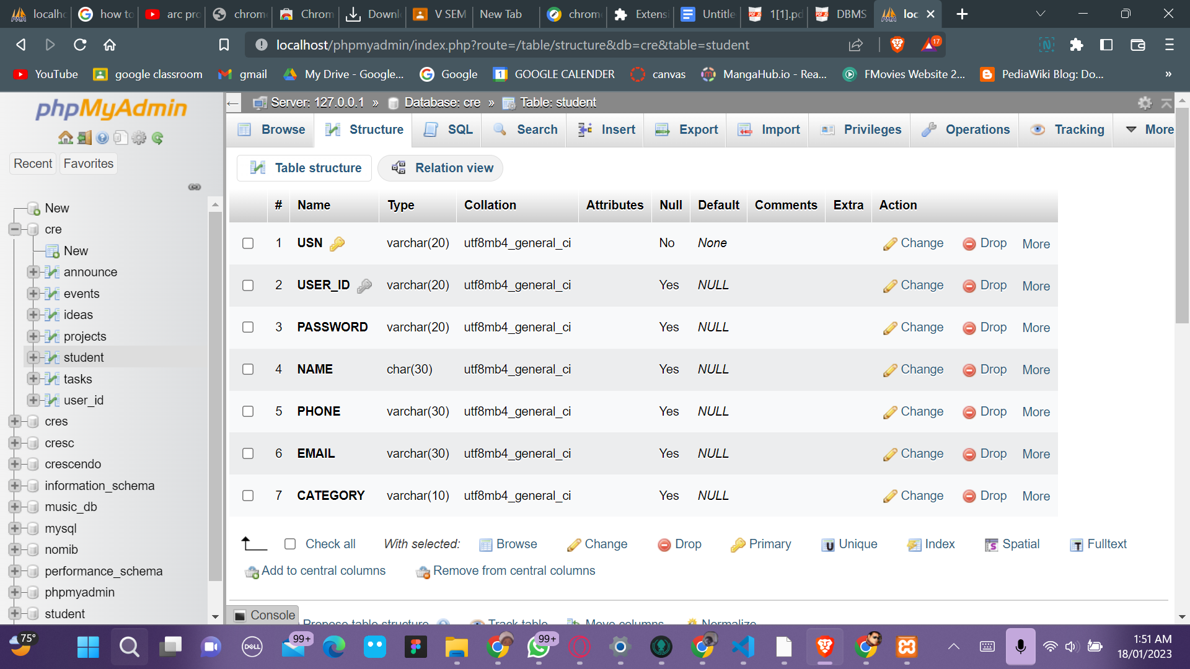

**Table 3.3.2 User_ID**

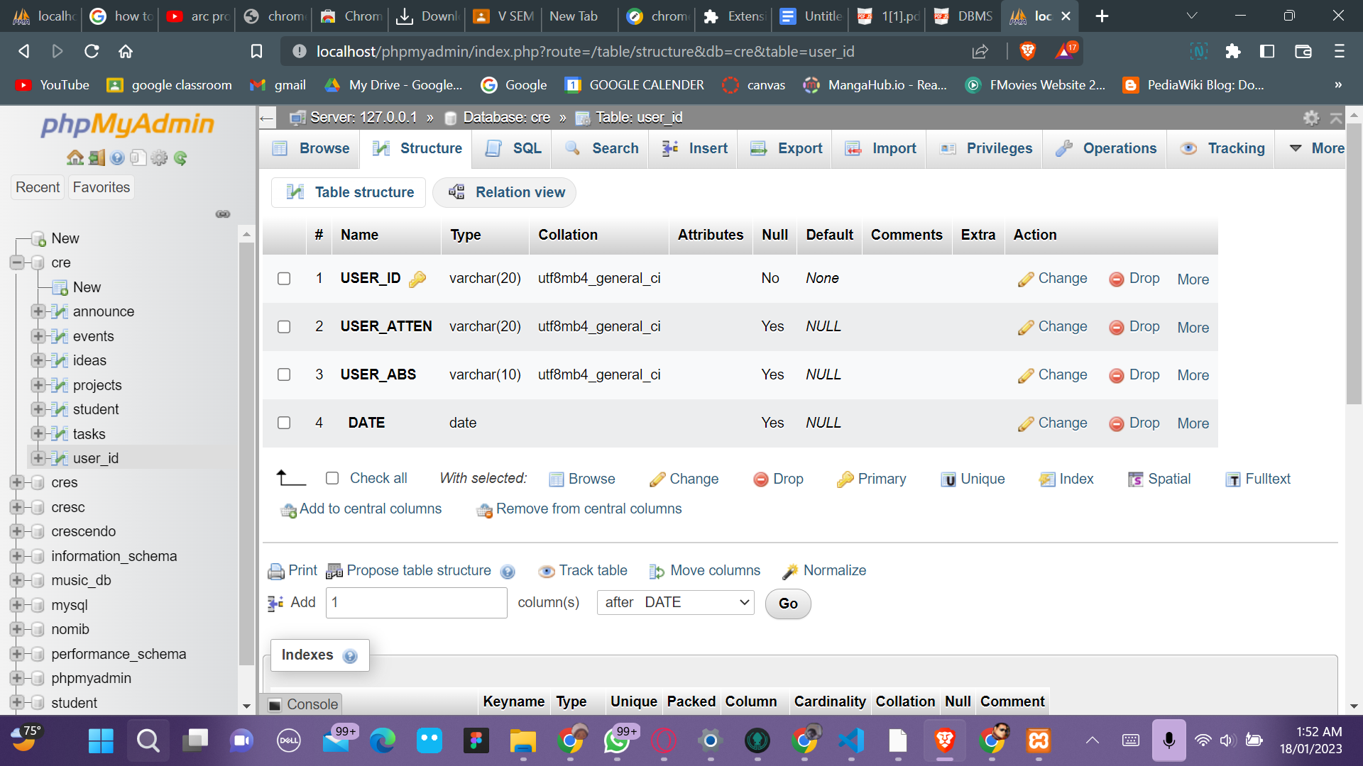

**Table 3.3.3 Projects**

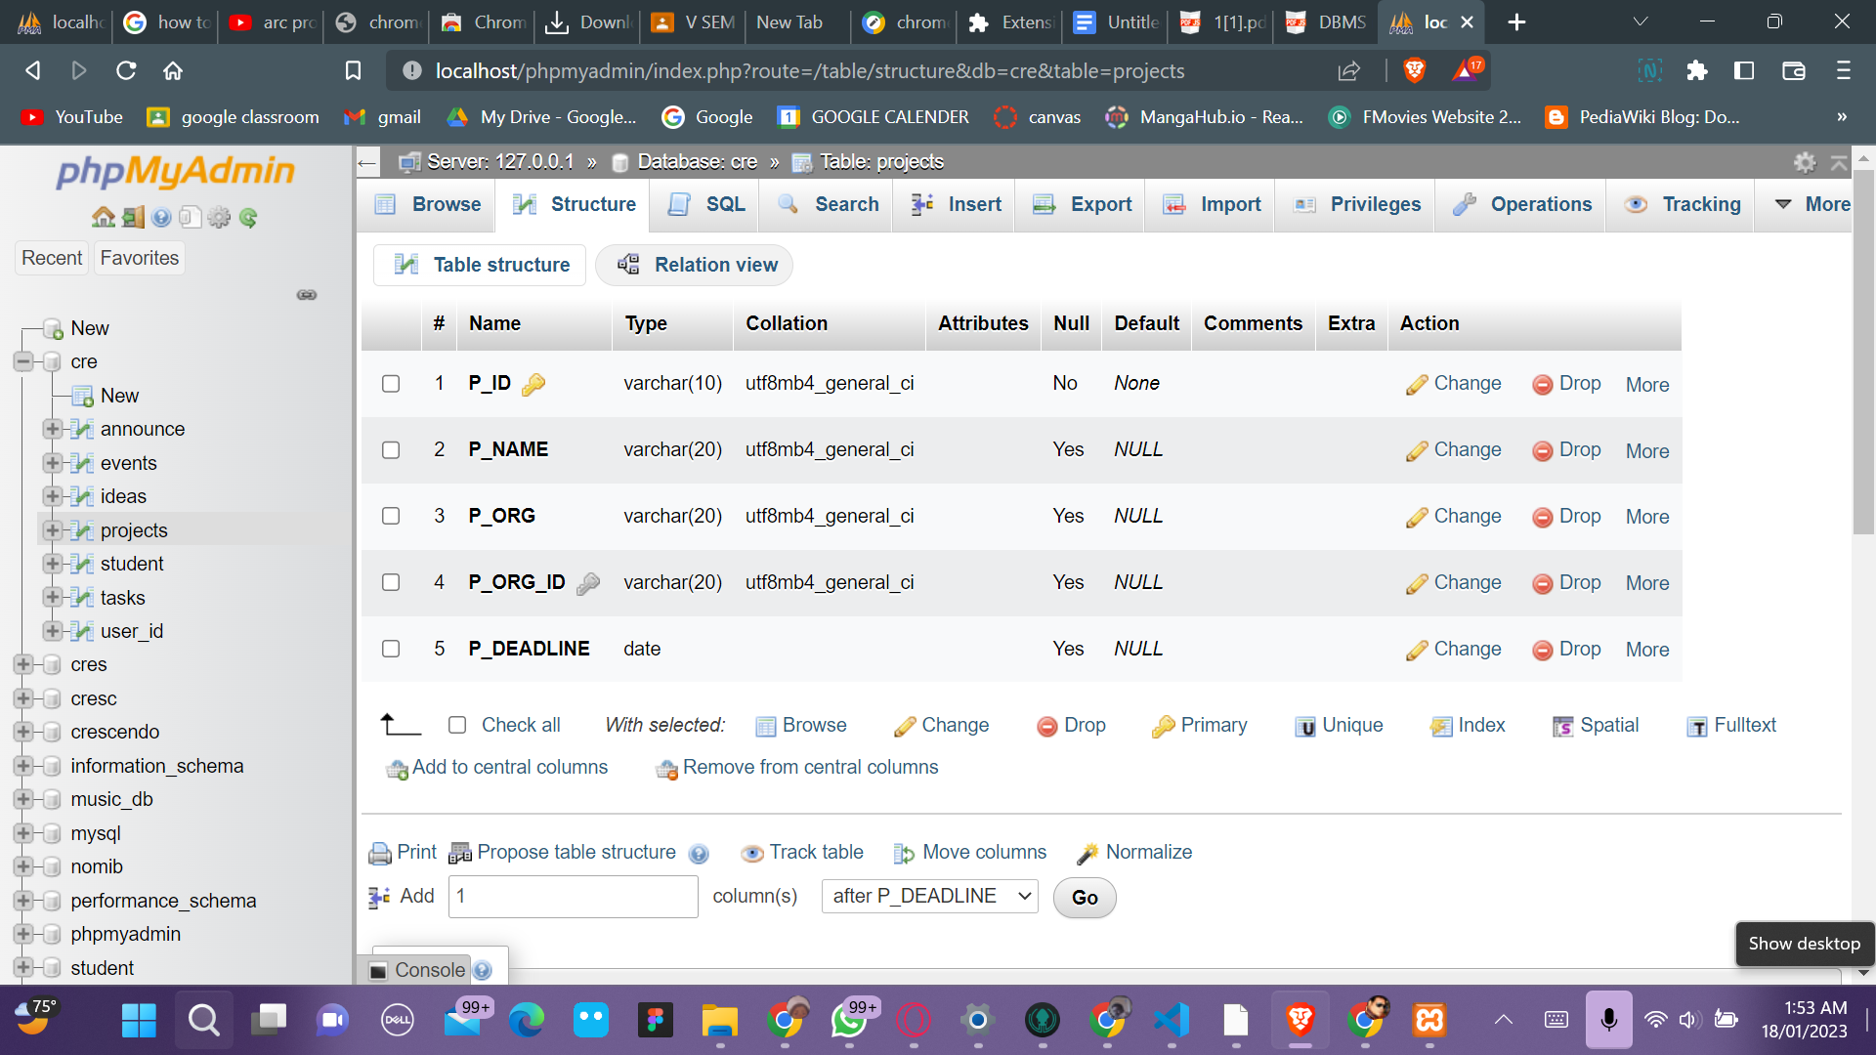

**Table 3.3.4 Tasks**

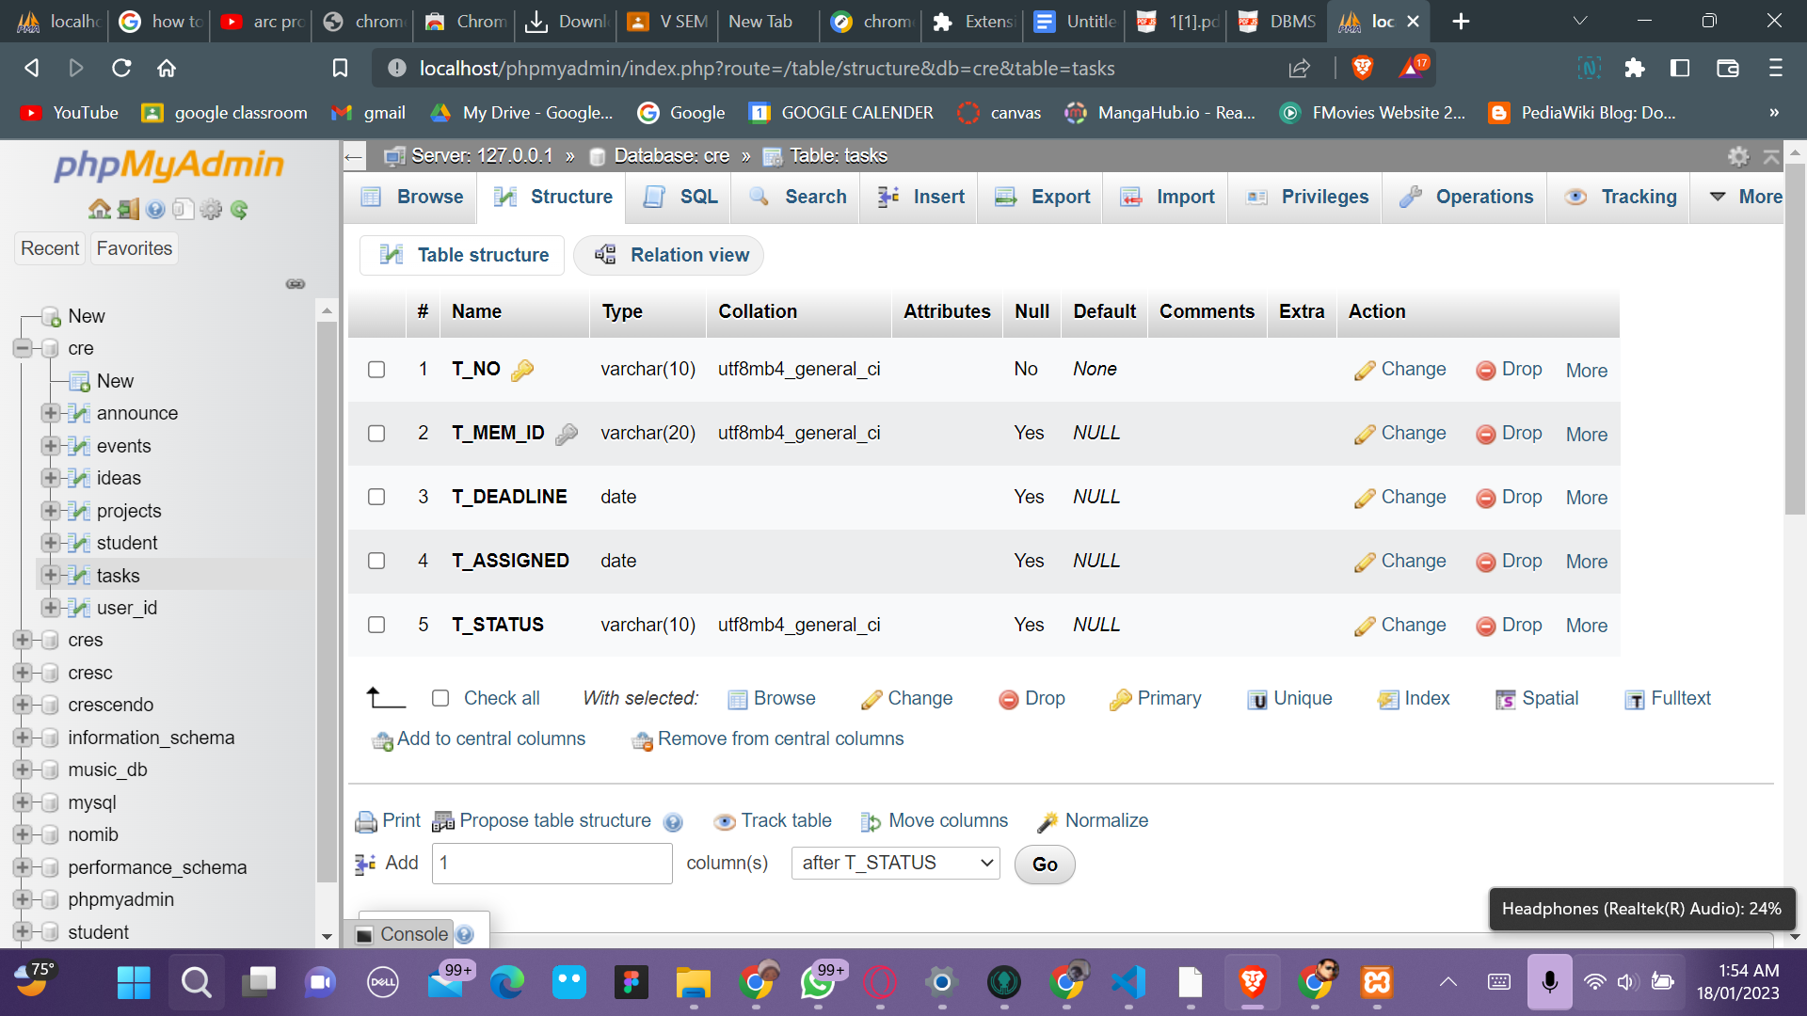

**Table 3.3.5 Ideas**

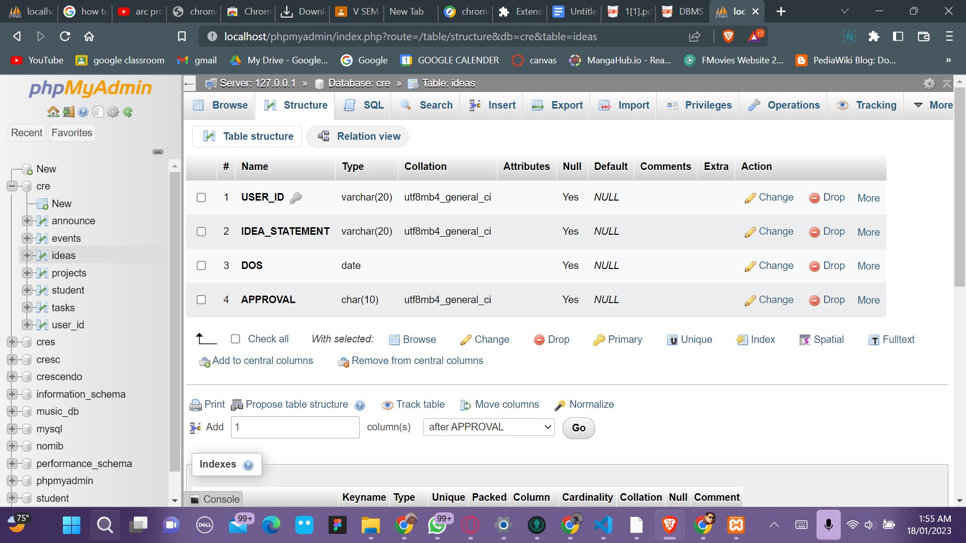

**Table 3.3.6 Announcements**

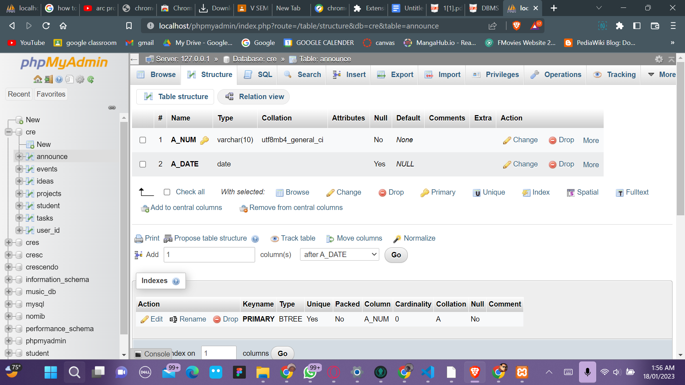

**Table 3.3.7 Events**

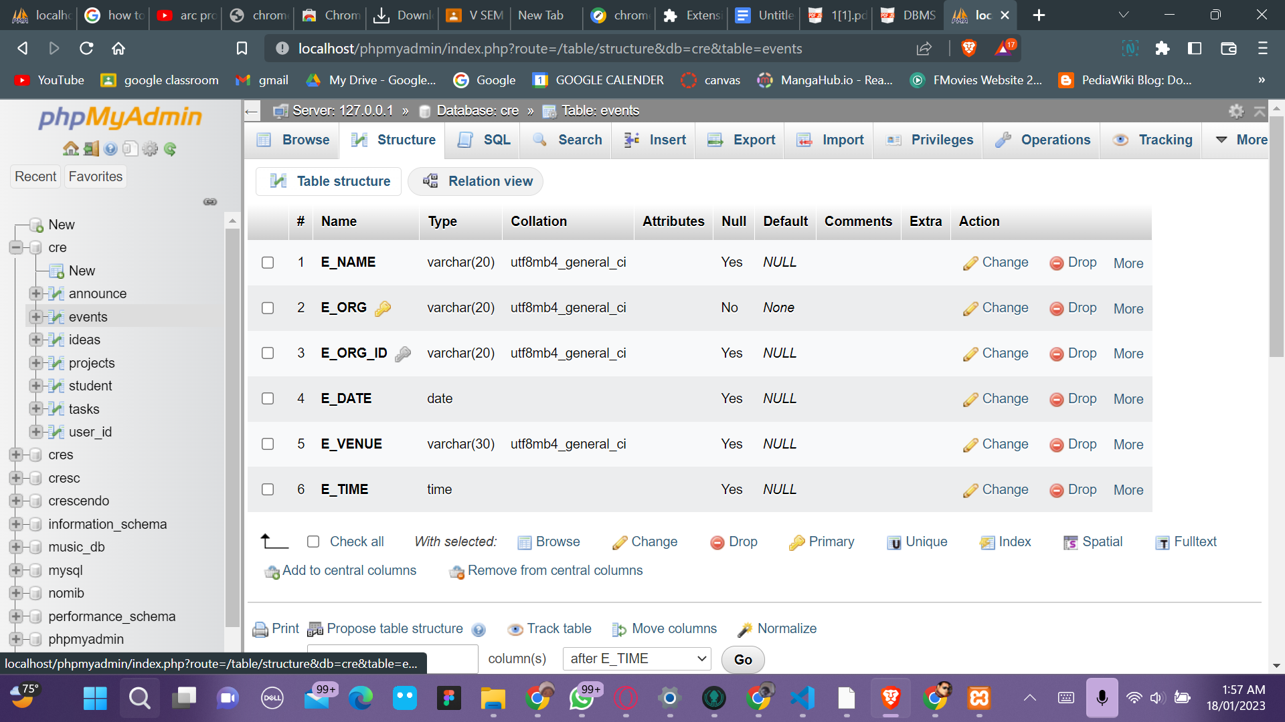

Screenshots

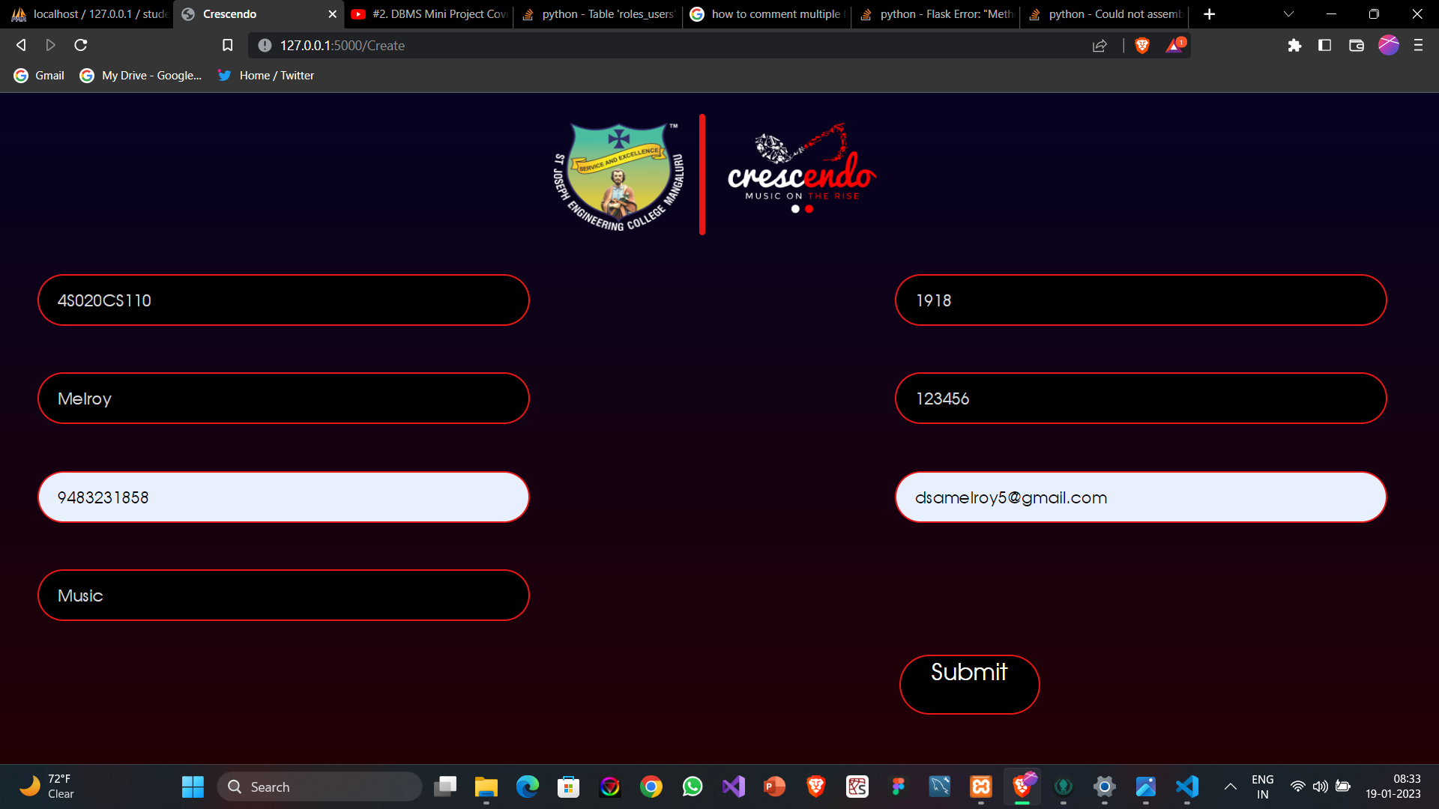

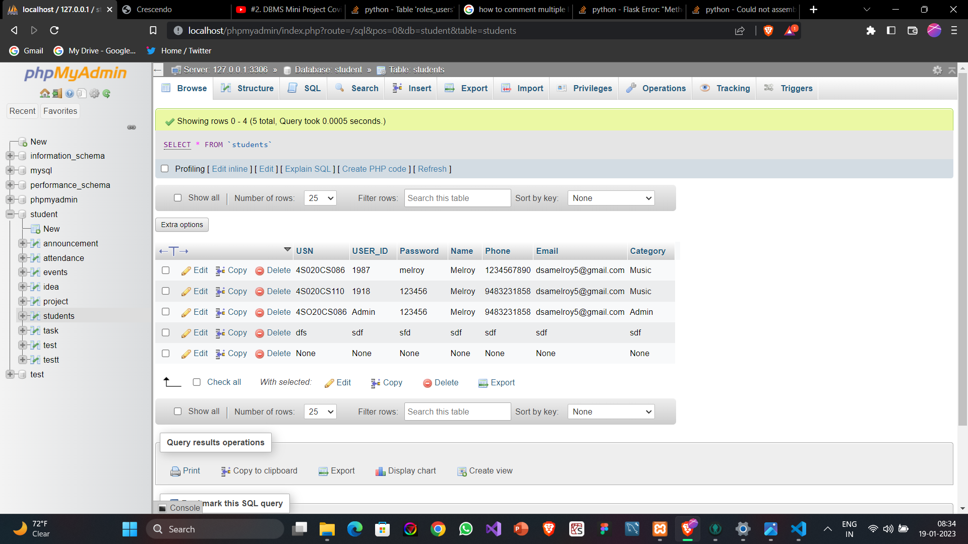

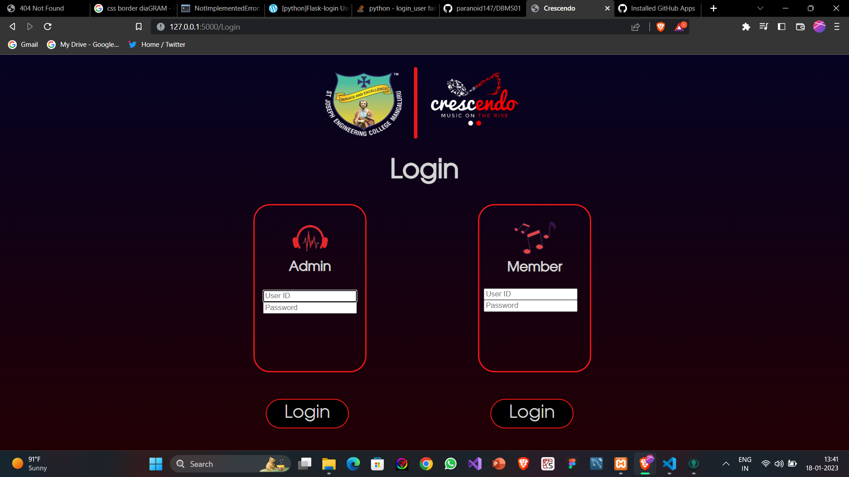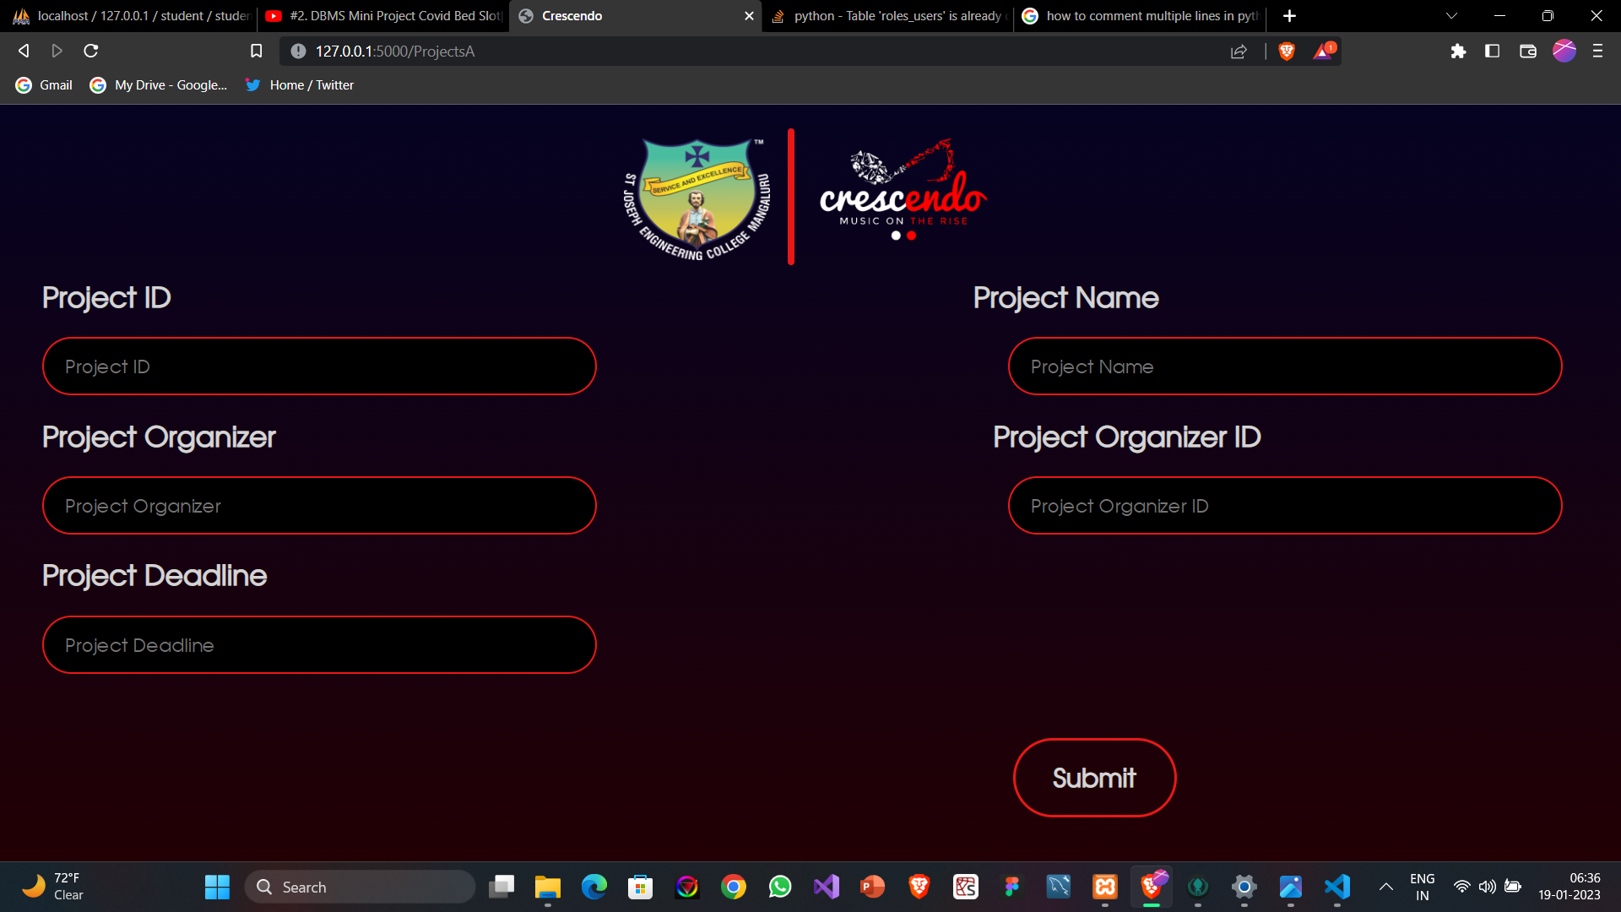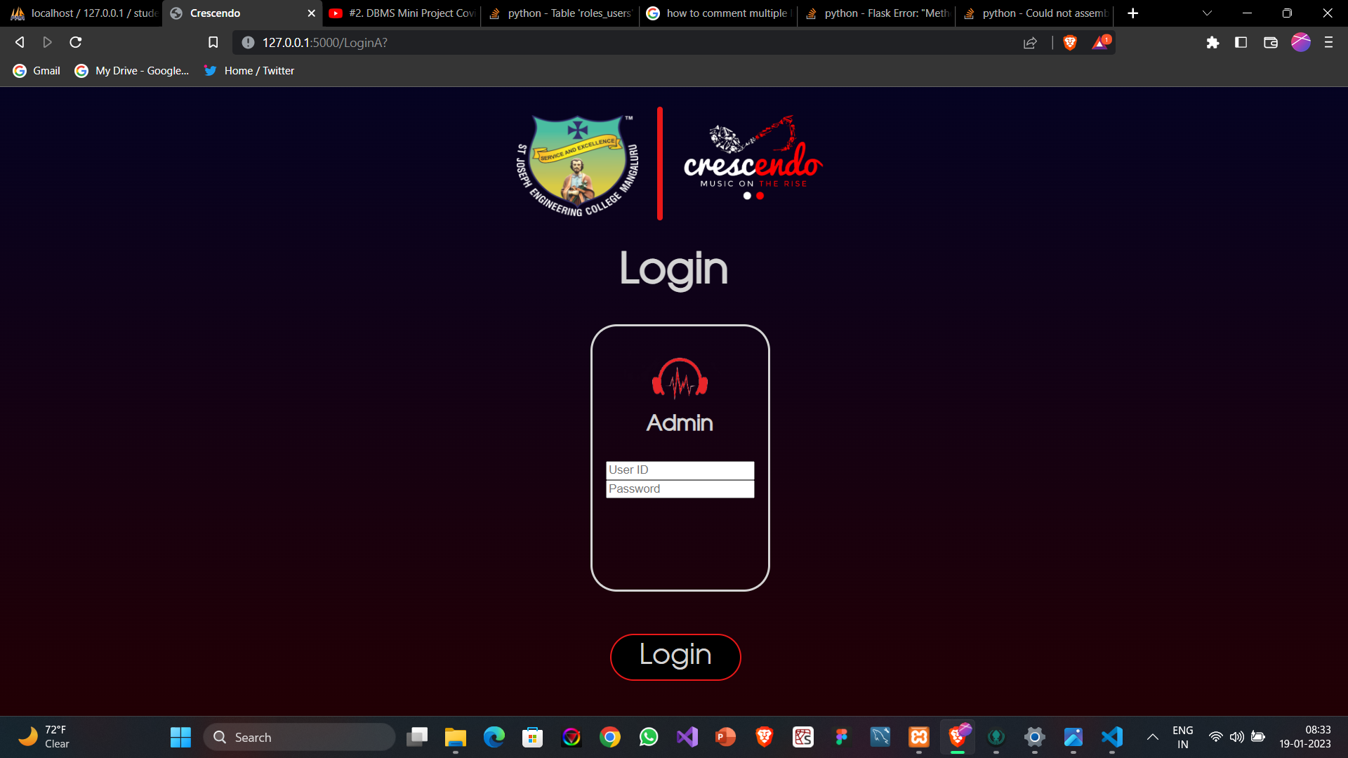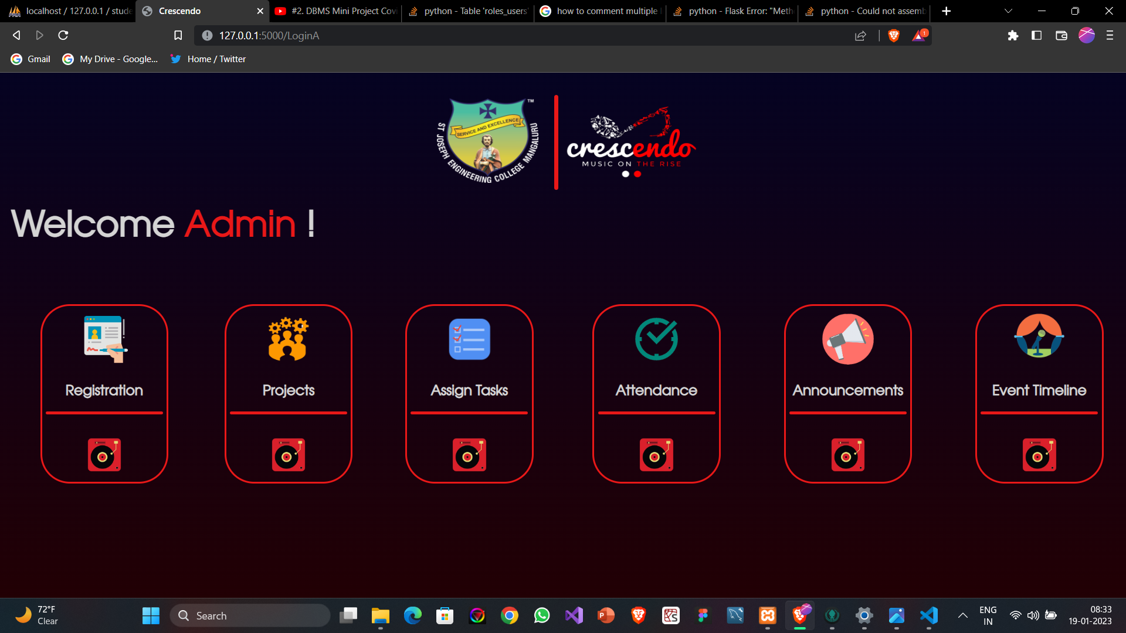

**Chapter-5 Conclusion and Future Work**

Crescendo-The Music Club System helped improve organizational structure by ensuring that student management was well-organized and that resources were used effectively.

This project is being implemented on a small scale for a small group of students, but as the student body grows, it may be expanded to a wider audience. useful to manage all data and conduct paperless wo

**REFERENCES**

**1.**[**https://youtube.com**](https://youtube.com)

**2.**[**http://ww17.w3cschools.com/js/js_datatypes.asp**](http://ww17.w3cschools.com/js/js_datatypes.asp)

**3.**[**http://ww17.w3cschools.com/php/php_forms.asp**](http://ww17.w3cschools.com/php/php_forms.asp)

**4.**[**http://ww17.w3cschools.com/sql/sql_update.asp**](http://ww17.w3cschools.com/sql/sql_update.asp)

**5.**[**http://ww17.w3cschools.com/sql/sql_insert.asp**](http://ww17.w3cschools.com/sql/sql_insert.asp)

**6.**[**https://www.youtube.com/watch?v=L5RpqspNAuc&t=191s**](https://www.youtube.com/watch?v=L5RpqspNAuc&t=191s)

**7.**[**https://www.youtube.com/watch?v=Avqr4Iqd2wg**](https://www.youtube.com/watch?v=Avqr4Iqd2wg)